Software Requirements Specification

Team-Up Android Application

Version 1.0 approved

Prepared by :-

(1)Yash Pratapwar

(2)Jayant Rajdhar

(3)Isha Wagh

(4)Hritvik Bagde

VIIT, Pune

Table of Contents

Table of Contents ii

Revision History ii

1. Introduction 1

1.1 Purpose 1

1.2 Document Conventions 1

1.3 Intended Audience and Reading Suggestions 1

1.4 Product Scope 1

1.5 References 1

2. Overall Description 2

2.1 Product Perspective 2

2.2 Product Functions 2

2.3 User Classes and Characteristics 2

2.4 Operating Environment 2

2.5 Design and Implementation Constraints 2

2.6 User Documentation 2

2.7 Assumptions and Dependencies 3

3. External Interface Requirements 3

3.1 User Interfaces 3

3.2 Hardware Interfaces 3

3.3 Software Interfaces 3

3.4 Communications Interfaces 3

4. System Features 4

4.1 System Feature 1 4

4.2 System Feature 2 (and so on) 4

5. Other Nonfunctional Requirements 4

5.1 Performance Requirements 4

5.2 Safety Requirements 5

5.3 Security Requirements 5

5.4 Software Quality Attributes 5

5.5 Business Rules 5

6. Other Requirements 5

Appendix A: Glossary 5

Appendix B: Analysis Models 5

Appendix C: To Be Determined List 6

Revision History

|  |  |  |  |
| --- | --- | --- | --- |
| **Name** | **Date** | **Reason For Changes** | **Version** |
|  |  |  |  |
|  |  |  |  |

# Introduction

## Purpose

Sports is a medium through which the world gets connected together. This Application acts as a medium to connect people from different corners through sports.

This enhances people to play sport frequently by giving information about the grounds in which is feasible for them to play.

This helps in connecting people who are just six to seven clicks away from them

and creates their interest in sport activities.

## Document Conventions

Times font with size 18 is used for main points and font Times 14 is used for sub-points .Font Times is used with size 12 for content.

App stands for application in this SRS document.

## Intended Audience and Reading Suggestions

This document is intended for Project guide, Experts and all other faculty members. It is also intended for developers who are interested in making android application related to sports.

## Product Scope

The project aims at reaching the milestone of maximum number of users/active players. Since the android users are in huge number hence android is chosen to be the platform. Certain assumptions are to be taken into account such as user has an android smart phone running on android 5.0 and above. Secondly user has the basic knowledge of using and downloading the application. The application works with certain constraints like android version, geographical location ,type of sport .

## References

* Head first Android Development
* youtube.com/ProgrammingKnowledge
* <https://developer.android.com/guide>
* Wikipedia.org/android +app+development

# 

# 2. Overall Description

## 2.1 Product Perspective

This product is a replacement to the conventional method of playing sports with other players.

It is a new, self-contained product.

Major components :-

1. Users

2. Android platform

3. Firebase

4. Resources

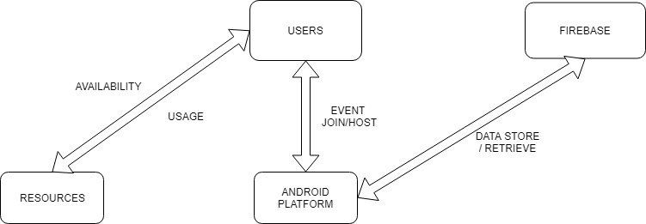

## 2.2 Product Functions

Major functions are :-

* Event join / host
* Finding users in a specific area
* Chatting facility

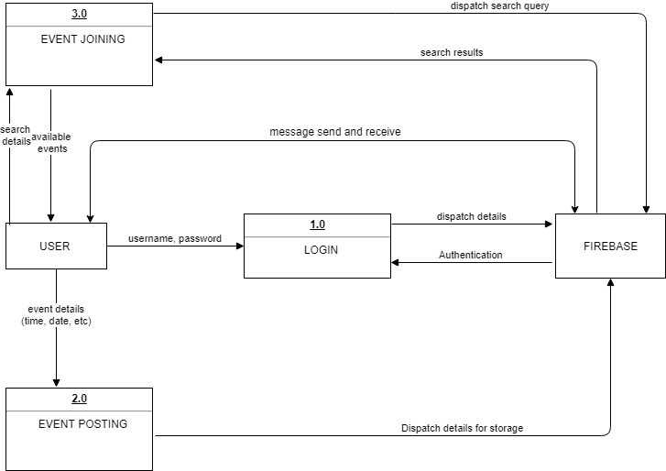

## 

## 2.3 Operating Environment

This application will run on android platform such as mobile phones and tablets. The android application should be executed on android version 5.0 and above.

There should a GPS facility in the mobile phone and minimum 512KBPS internet speed.

## 2.4 Design and Implementation Constraints

The proposed android application is solely developed on Android Studio. Firebase dependencies are added to the designated folders in the project view. Code for the same is integrated within the source code. Firebase is used as database for event information and also as chat database. User authentication is also done using Firebase. Design of the application is completely coded in XML while logical part of each module is written in java.

## 2.5 User Documentation

* Application Tour
* Help page
* Tutorials

## 2.6 Assumptions and Dependencies

Assumptions while developing this application are:-

* User device is an Android device running on Android 5.0 and above
* Any wearable device is not used
* Device has working GPS
* Reliable internet connection is available (Ideally 512 Kb/ps and above)
* User has basic knowledge of using applications

Dependencies are:-

* Map API is integrated within the application
* Firebase APIs are integrated in the application

# 3 External Interface Requirements

## 3.1 User Interfaces

User has to interact with minimum 7 to maximum 11 pages according to User’s choice.

Login page asks for username and password and also has only one ‘login’ button. Register page asks for details which includes email-id, contact number and password.

Next page is for selecting type of sport from three options. Each option acts as a button.

All sports of selected sport are displayed on the next page. According to user’s choice next page will be to post event or to join event where all the details of time and address are going to be asked. Sample screen images are given below.

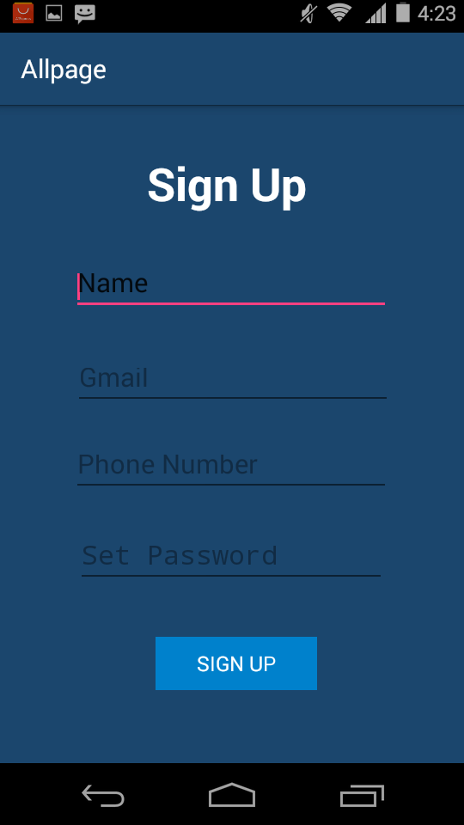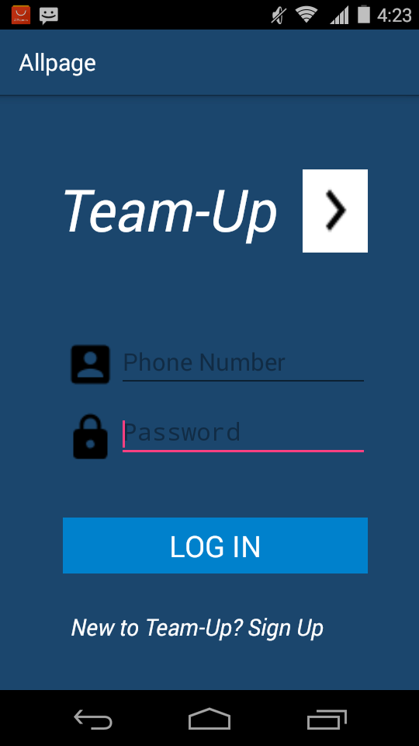

## 3.2 Hardware Interfaces

Supported devices are all Android devices running on android 5.0 and above except wearable and TV. The data to be stored or retrieved is text data. The device needs to be connected to internet for interaction between device and back end of the system.

## 3.3 Software Interfaces

Connection between Android application and Firebase is done using integration code for the same.

Version of Firebase used for development is version 16.0.2. Google Ads acts as the commercial component.

## 3.4 Communications Interfaces

Basic level chatting application without any kind of encryption. XMPP protocol which is Extensible Messaging and presence protocol. It is an open XML standard and technology allows building real time communication chatting module. Both XMPP and firebase help to create chat application on android platform.

# 4. System Features

## 4.1 Login

4.1.1 Description and Priority

This feature will be used to LOG IN into the application by the user. It is done inorder to prevent any misuse of user account. priority is high.

4.1.2 Stimulus/Response Sequences

When the user gives the correct usemame and password combination, he/she is transferred to the main screen or the home page.

4.1.3 Functional Requirements

1.Purpose

To check the credibility of an user and to prevent any misuse of the product

2.Inputs

The input will be username and password combination

3.Output

The user will be transferred to the main page on successful validation and will be alerted if the validation is unsuccessful.

## 4.2 New user Registration/SignUp

4.2.1 Description and Priority

Its purpose is to create a new user account. A user must be registered

before he/she can create any new event invitation for any sport/game.priority is high.

4.2.2 Stimulus/Response Sequences

On successful validation of each datafield (user details, the registration takes place and the success message is displayed.

4.2.3 Functional Requirement

1.Purpose

To register a new user

2.Inputs

The required data for registration/signup of a new user (Like Name, location, favoured sport etc)

3.Output

A Success Message be displayed on successful registration or else an error message will be displayed

**4.3 Create an invitation**

4.3.1 Description and Priority

This feature will be used by the account user. whenever any user wants to play any sports/game he can create an open invitation of that sport/game. the user can fill invitation details like venue, date and time, no. of players, resources available etc. priority is high.

4.3.2 Stimulus/Response Sequences

When the user gives fill all the required details for posting an invitation an individual block is created and is broadcasted to every user nearby the host user.

4.3.3 Functional Requirement

1.Purpose

To create an Invitation for any sports/games

2.Inputs

The input will be venue, date and time, resource available, no. of players

3.Output

The other user nearby the host user can see the Invitation and if favourable to them can approach the host through message and accept invitation button.

**4.4 Search for invitation**

4.3.1 Description and Priority

This feature will be used by the account user to search any existing invitation favourable to him/her.priority is high.

4.3.2 Stimulus/Response Sequences

The user must search for the sports/games he is interested in and the list of host players invitations will appear on the screen.

4.3.3 Functional Requirement

1.Purpose

To search for the existing Invitations.

2.Inputs

The input will be the name of sports/game in the search box.

3.Output

The user will be shown the list of existing invitations nearby him with all details. the user can accept the invitation through accept button.

# 5.Other Nonfunctional Requirements

5.1 Performance Requirements

The most important factor in the working of the whole project is its Connectivity with the Server ,the Mode of communication and the smooth working of the application.

5.2 Safety Requirements

Not Applicable

5.3 Security Requirements

The Central Server comprises of the Google Fire base is open

source software solutions and the best among their fields. It has it’s Security Mechanism which would prevent any unauthorised access or exploitation of the Server

5.4 Software Quality Attributes

This project would be developed completely using open source software.

5.5 Business Rules

Not Applicable

5.6 Special User Requirements

The users should have knowledge of the sports/game he/she wishes to create/accept invitation.Also should have knowledge for using the product except that they should know about browsing and surfing

5.6.1 Backup and Recovery

Not Applicable at present

5.6.2 Data Migration

Not Applicable present